Redox

1. Reduction-Oxidation Reactions- electrons are transferred from one atom to another are called oxidation–reduction reactions. Redox reactions for short

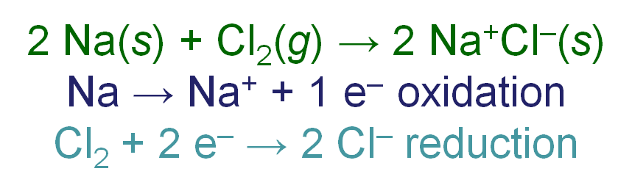

Atoms that lose electrons are being oxidized

Atoms that gain electrons are being reduced.

2. Oxidation is the process that occurs when

* the oxidation number of an element increases,
* an element loses electrons,
* a compound adds oxygen,
* a compound loses hydrogen, or
* a half-reaction has electrons as products.

3. Reduction is the process that occurs when

* the oxidation number of an element decreases,
* an element gains electrons,
* a compound loses oxygen,
* a compound gains hydrogen, or
* a half-reaction has electrons as reactants.

. **LEO the Lion Says GER**

a. Loss of Electrons is OXIDATION

i. oxidation number increases from reactant to product

b. Gain of Electrons is REDUCTION

i. oxidation number decreases from reactant to product.

4. **Oxidation Number (Oxidation State)** – a method of keeping track of electrons gained by the substance reduced and lost by the substance oxidized.

5. **Rules for assigning oxidation numbers**

a. Atoms in their elemental form have an oxidation number of zero. Cu = 0

b. Monatomic ions have an oxidation number equal to their charge. K+1= +1.

c. Nonmetals have negative oxidation numbers.

i. Oxygen is -2 in all compounds with the exceptions of peroxides in which it is -1

ii. Hydrogen is usually +1 with nonmetals

Hydrogen is usually -1 with metals

d. The sum of the oxidation number in an neutral atom is zero.

6. Half Reactions

* We generally split the redox reaction into two separate **half-reactions**—a reaction just involving oxidation or reduction.
  + The oxidation half-reaction has electrons as products.

The reduction half-reaction has electrons as reactants.

7. **Balancing Oxidation-Reduction Equations in Acidic Solutions**

1. Assign oxidation states.

a) Determine the element oxidized and the element reduced.

2. Write oxidation and reduction half-reactions, including electrons.

a)Oxidation electrons on right, and reduction electrons on left of the arrow.

3. Balance half-reactions by mass.

a) First balance elements other than H and O.

b) Add H2O where O is needed.

c) Add H+ where H is needed.

d) If the reaction is done in a base, neutralize H+ with OH−.

4. Balance half-reactions by charge.

a) Balance charge by adjusting electrons.

5. Balance electrons between half-reactions.

6. Add half-reactions

7. Check by counting atoms and total charge.

MnO4-+ SO32- → Mn2+ + SO42-

8. Electric Current Electrons flow through a conductor in response to an electrical potential difference similar to water flowing downhill in response to a difference in gravitational potential energy.

Electric current – the amount of electric charge that passes a point in a given period of time

Whether as electrons flowing through a wire, or ions flowing through a solution.

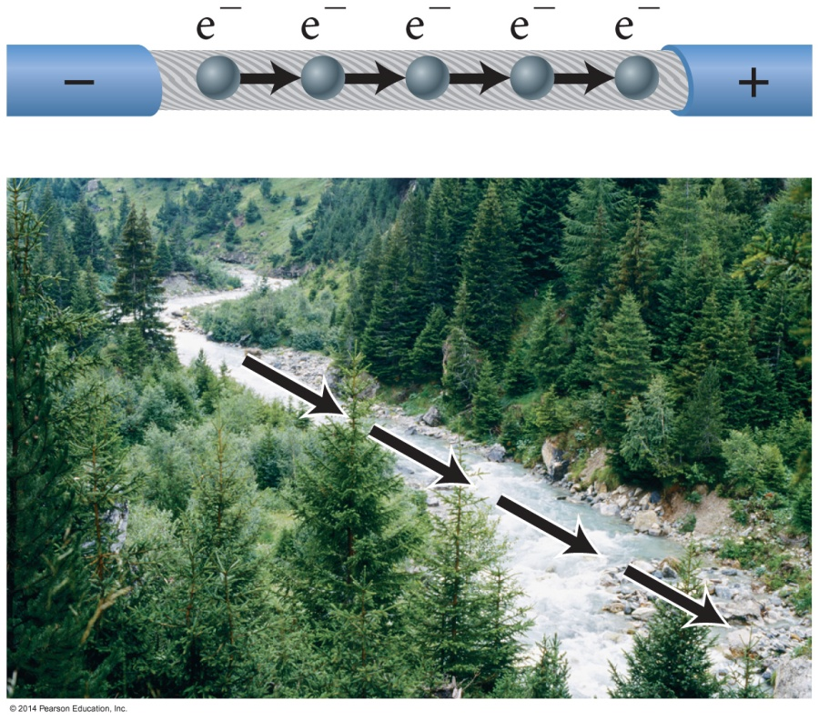

9. Redox Reactions and Current

* Redox reactions involve the transfer of electrons from one substance to another.
* Therefore, redox reactions have the potential to generate an electric current.
* To use that current, we need to separate the place where oxidation is occurring from the place where reduction is occurring.